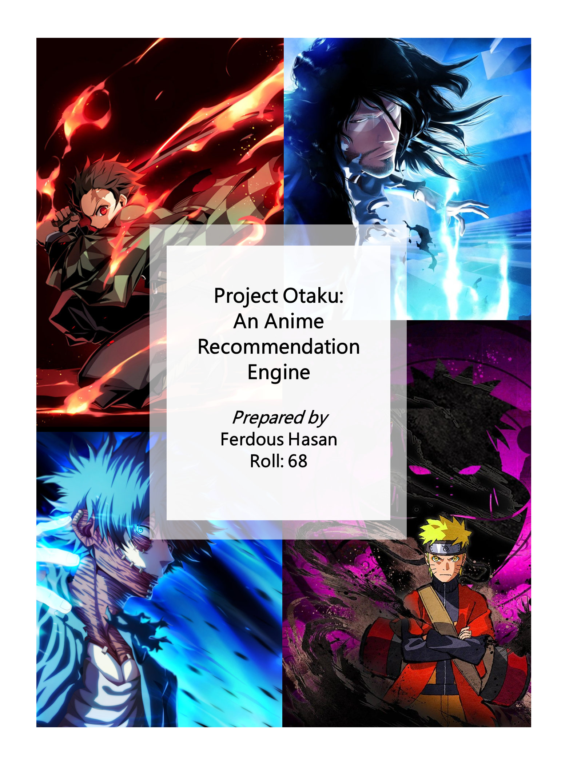

# Exploratory Visualization:

The first section of the assignment hopes to conduct extensive exploratory visualization to unearth significant and subtle associations or relationships between the variables. The relationships will identify trends which lead to an anime’s success and identify similarity patterns of content consumption for several user groups.

## Key Indicators:

The judgement parameters: rating (average rating out of 10 for the anime) and the members (number of community members of the anime’s group/ fanbase) have been visualized at first. This is because these variables are the key indicators of anime success, knowledge of which is essential for the interpretation of any further visualizations.

**Rating:** The first key indicator, rating, follows a distribution which is slightly skewed to the right as the median (6.57) is greater than the mean (6.47). The 25th percentile and the 75th percentile are rating scores of 5.88 and 7.18 out of 10 respectively.

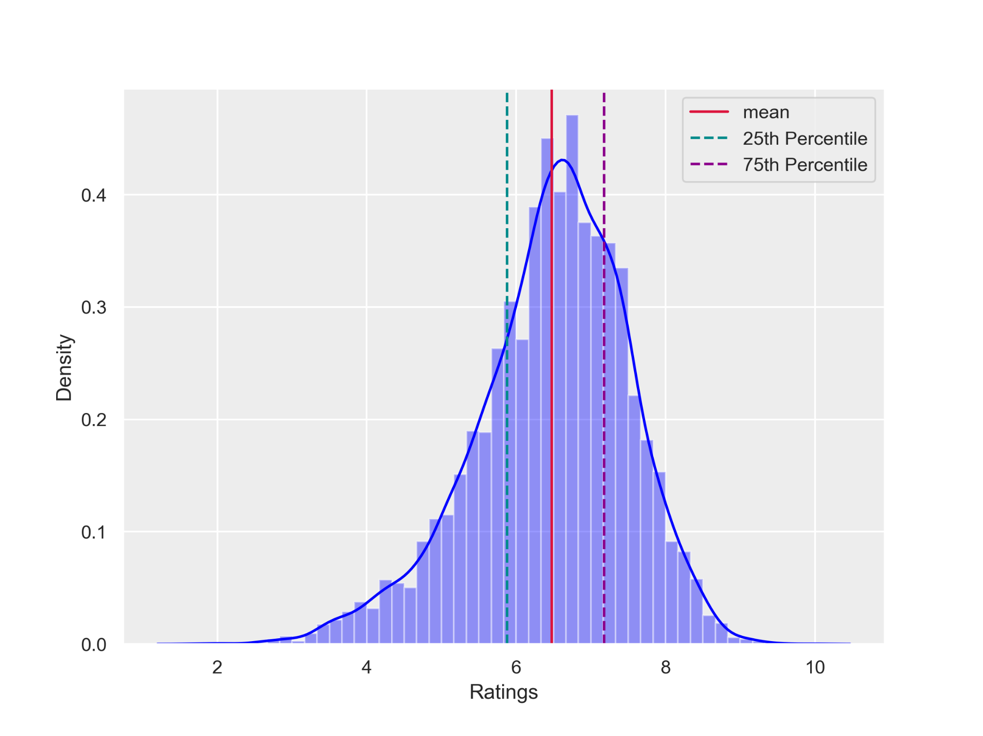

**Members:** While rating suggests whether an anime is likeable or not, members (fanbase) suggest the popularity level of the anime. Majority of the anime have 0 to 100,000 members in their fanbase. However, extremely few anime go on to have members greater than 300,000. The average fanbase size is 18071 is calculated at members.

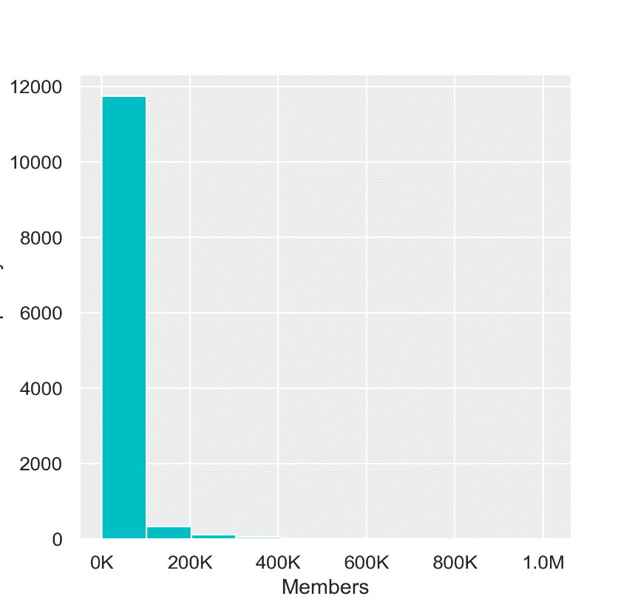

However, the median is 1550 members only, with the 25th percentile and the 75th percentile at 225 members and 9437 members only. Even after taking only the 0-100K group the continues to be highly skewed to the right.

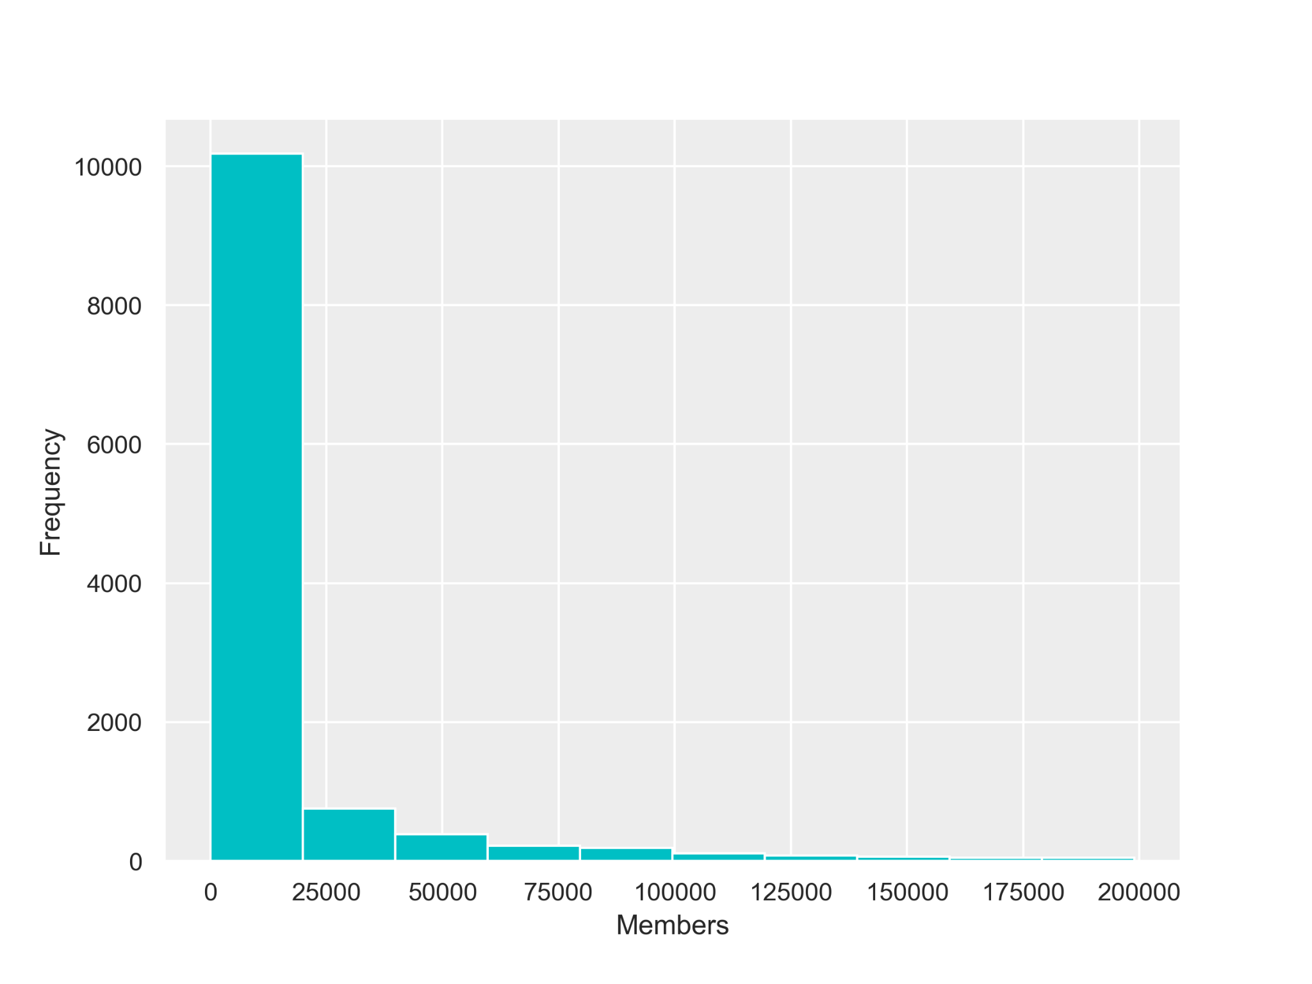

**Relationship between Rating and Members:**

The trend shows that despite having high ratings, there is a group of anime which has obtained a low number of members (popularity) despite having high ratings. Therefore, high ratings do not lead to success. However, it can be concluded that animes with poor ratings do not become popular (e.g. there has not been a single anime below the rating of 6, which has obtained more than 200,000 community members). Therefore, a good rating can be said to be a prerequisite for gaining popularity.

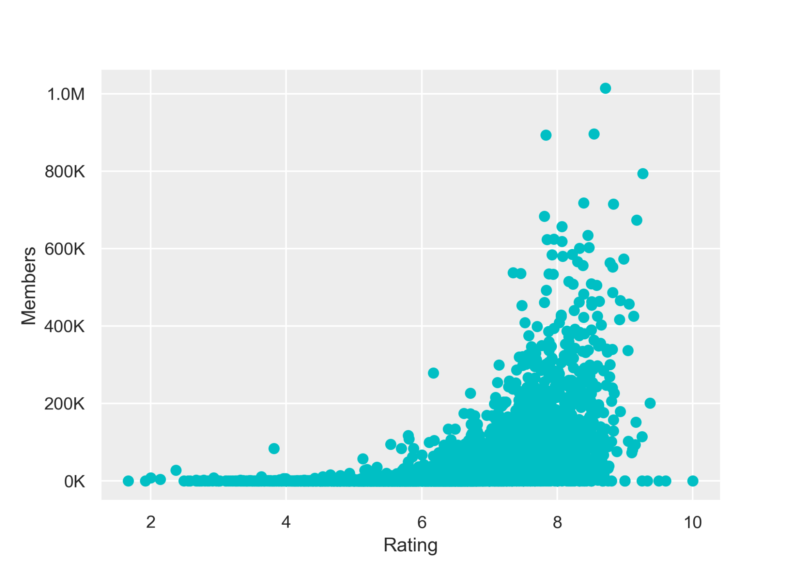

## Visualization by Genre:

A word cloud was visualized where the font size of each of the genre is proportional to the frequency of occurrence of the genre. Comedy, action and adventure are the most common anime types in the dataset as they have the greater frequencies as presented by the word cloud. Others popular genres include Sci-Fi, Romance, Fantasy, Shounen, Drama, etc.

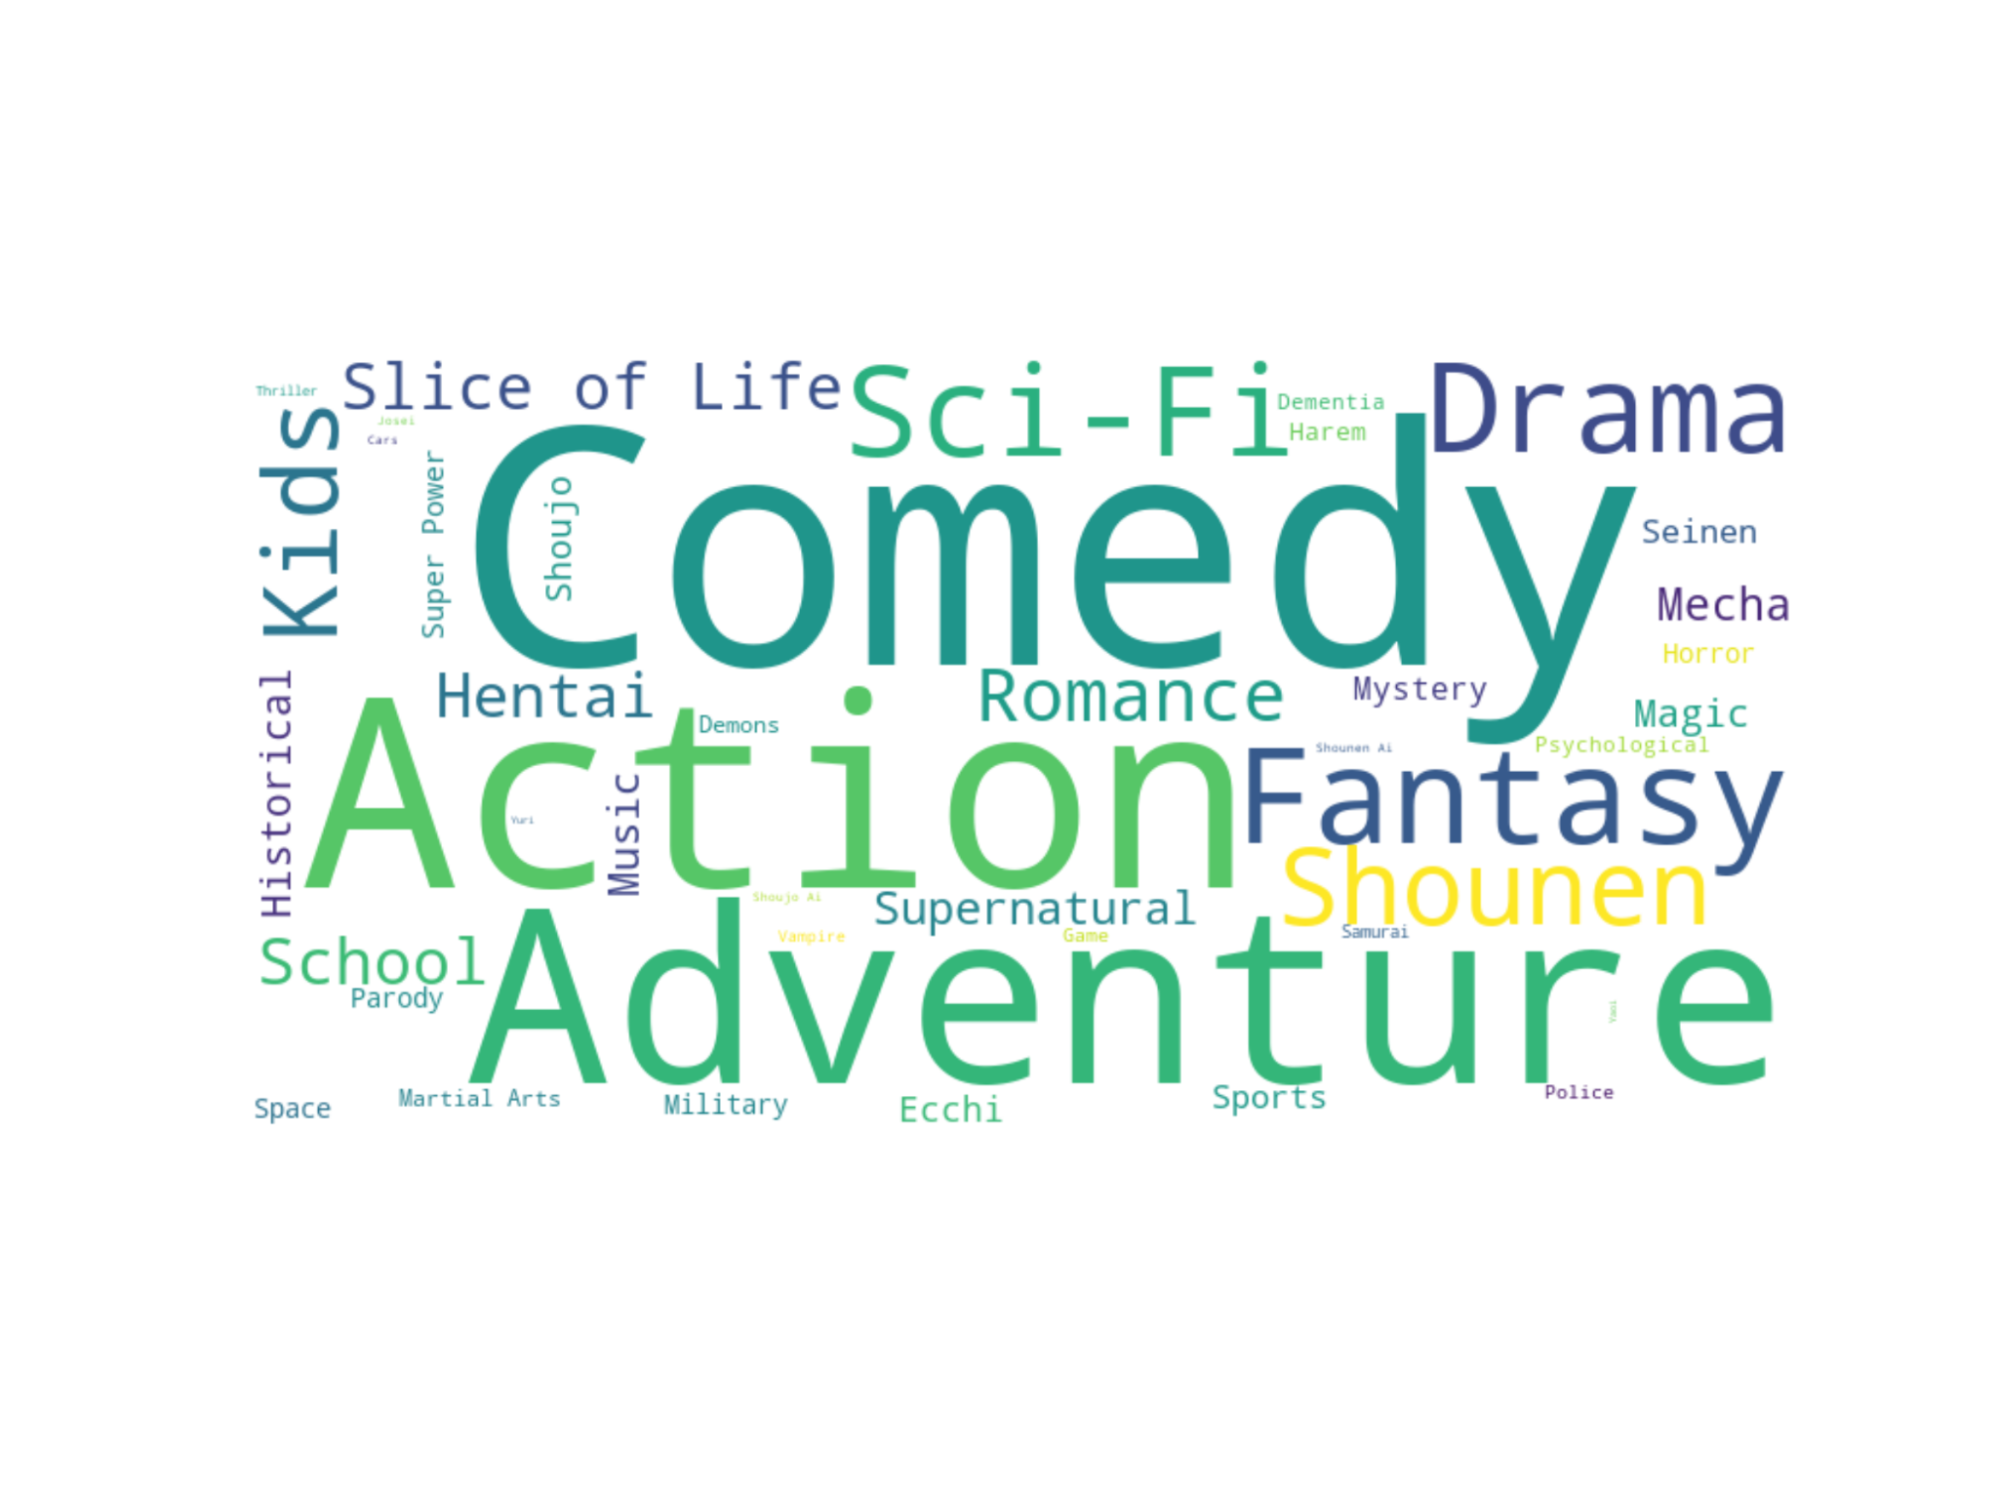

Most animes can be classified into multiple genres. Only 2866 animes (23%) have a single genre and 9428 animes (77%) have multiple genres. Animes have been recorded to have a maximum of 13 genres.

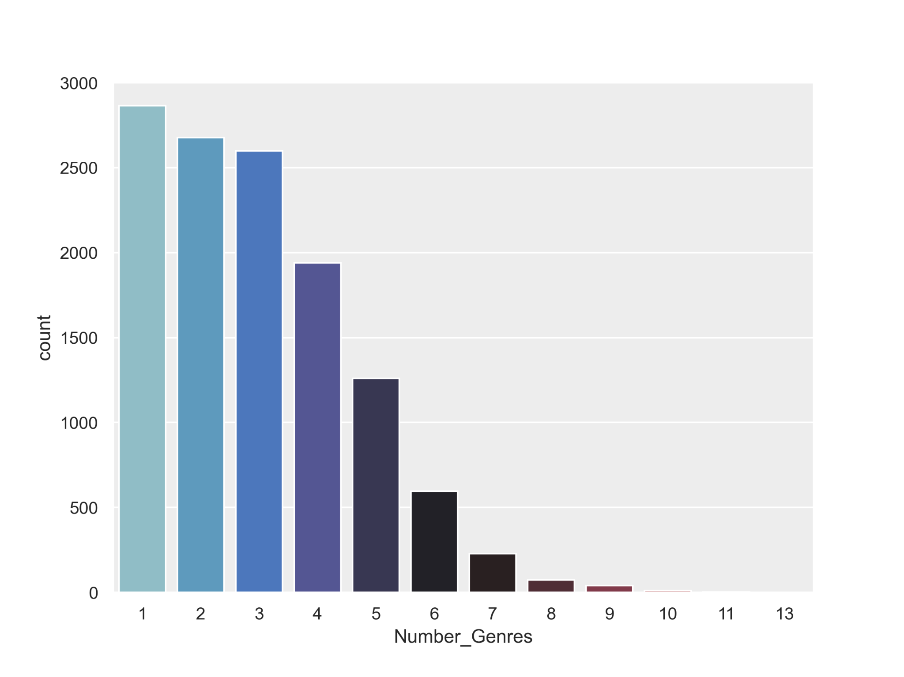

An seen in the visualization an interesting fact is that the rating of the genres consistently increases as the number of genres increases upto the genre number of 7.

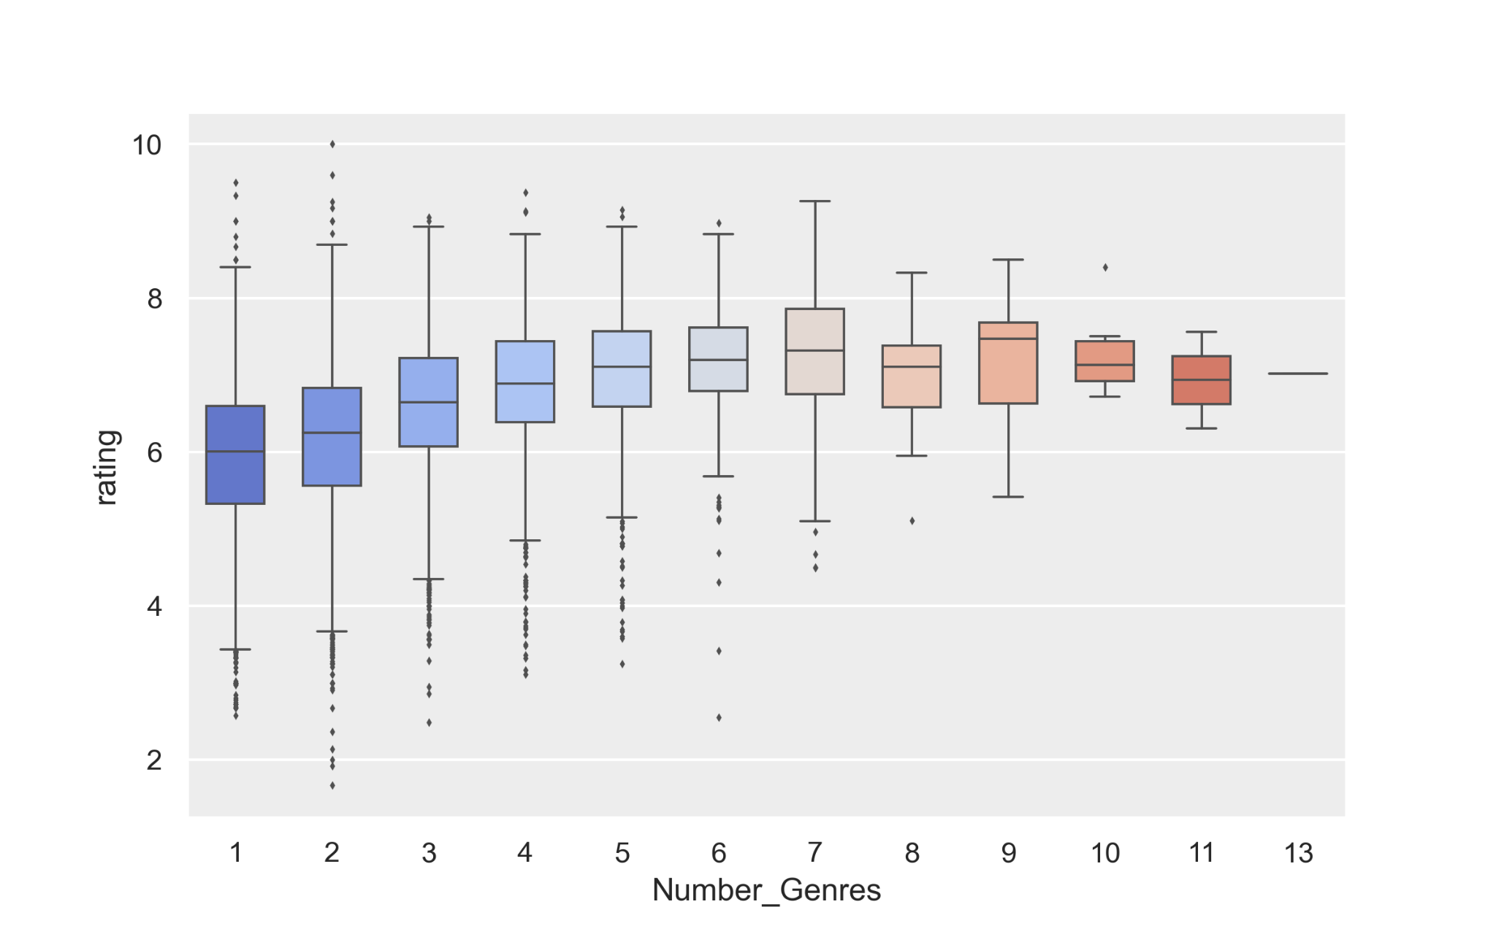

## Visualization by Release Medium:

Type of anime format or type of release of anime can be classified into 6 categories. TV is the most common type of anime format. TV, OVA and Movie together make up 77% of all animes.

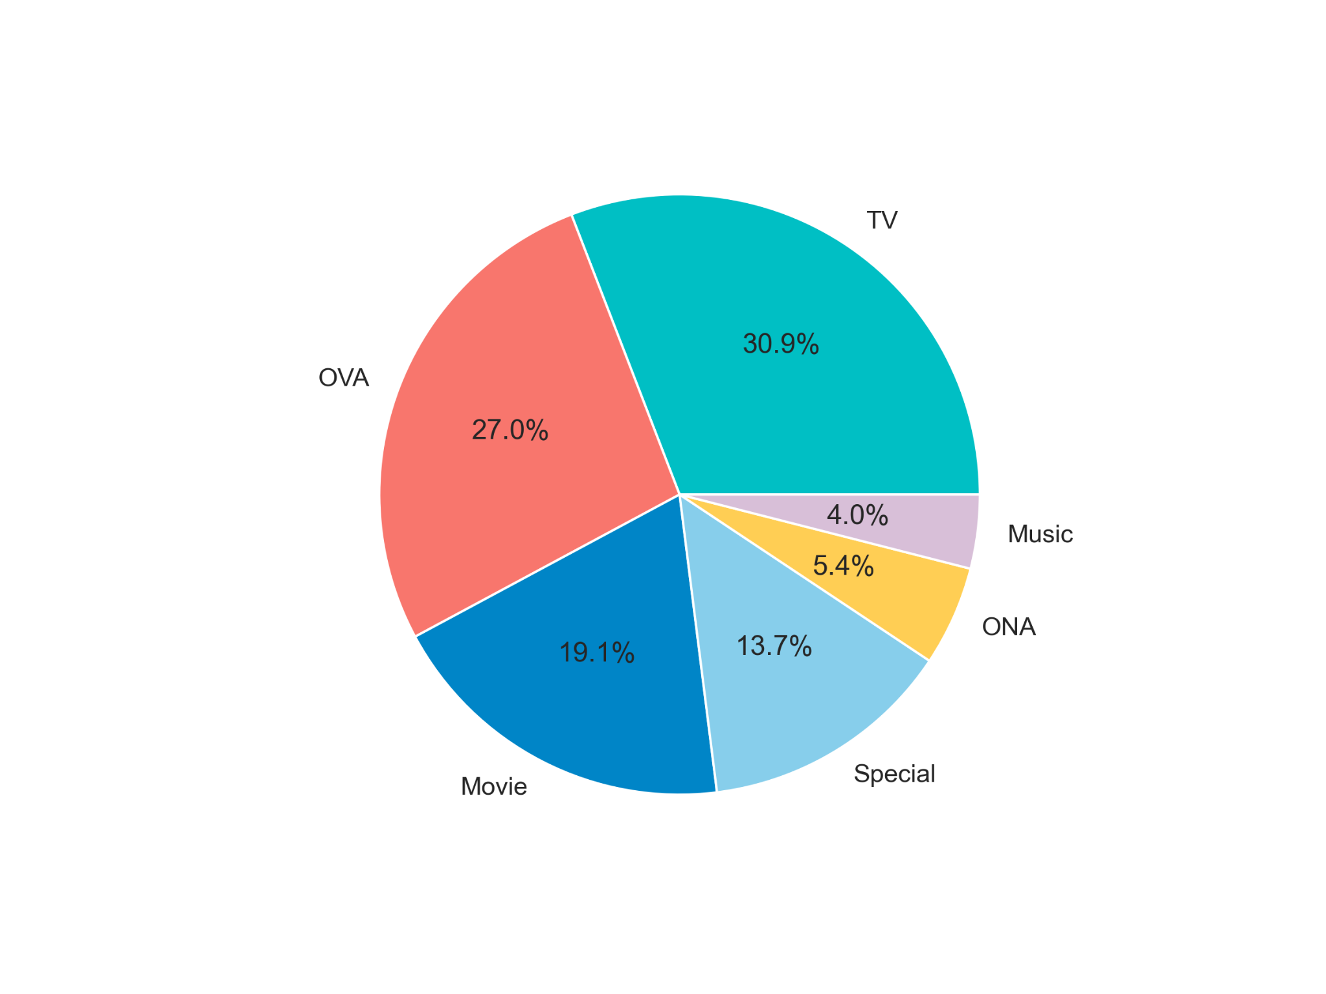

TV has the highest rating among the anime formats, followed by Movie, Special and OVA, ONA and Music. However, Movies have shown the highest variation as represented by the 75th and 25th percentile.

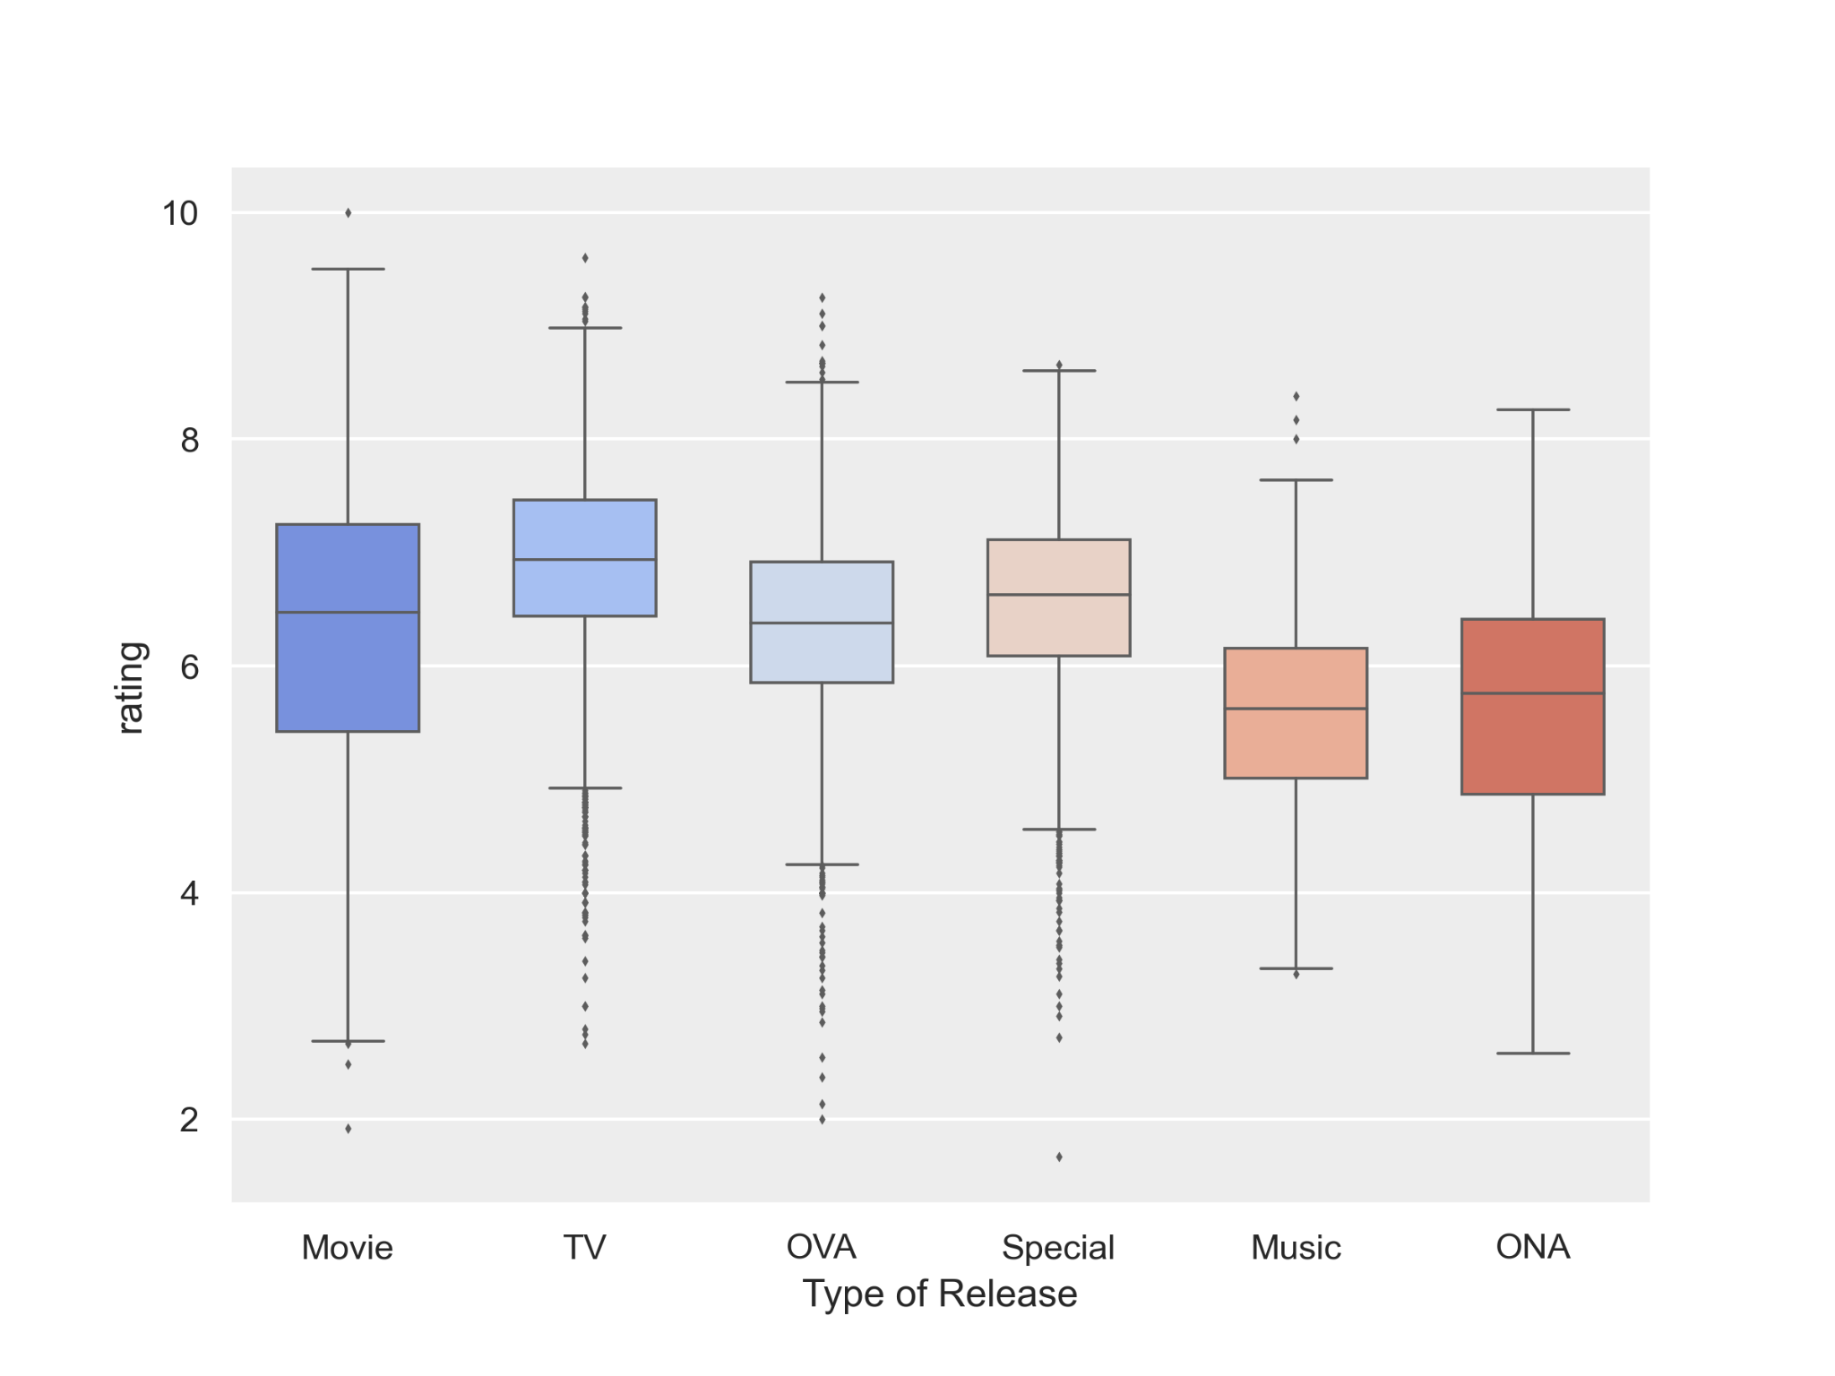

## Visualization by Episode:

The anime releases have an average value of 12.38. The number of episodes is highly influenced by the ‘Movie’ and ‘Specials’ anime formats which have only 1 episode, since animes with 1 episode’s account for 46% (5677 out of 12294) of all animes. A maximum of 1818 episodes has been recorded for an anime.

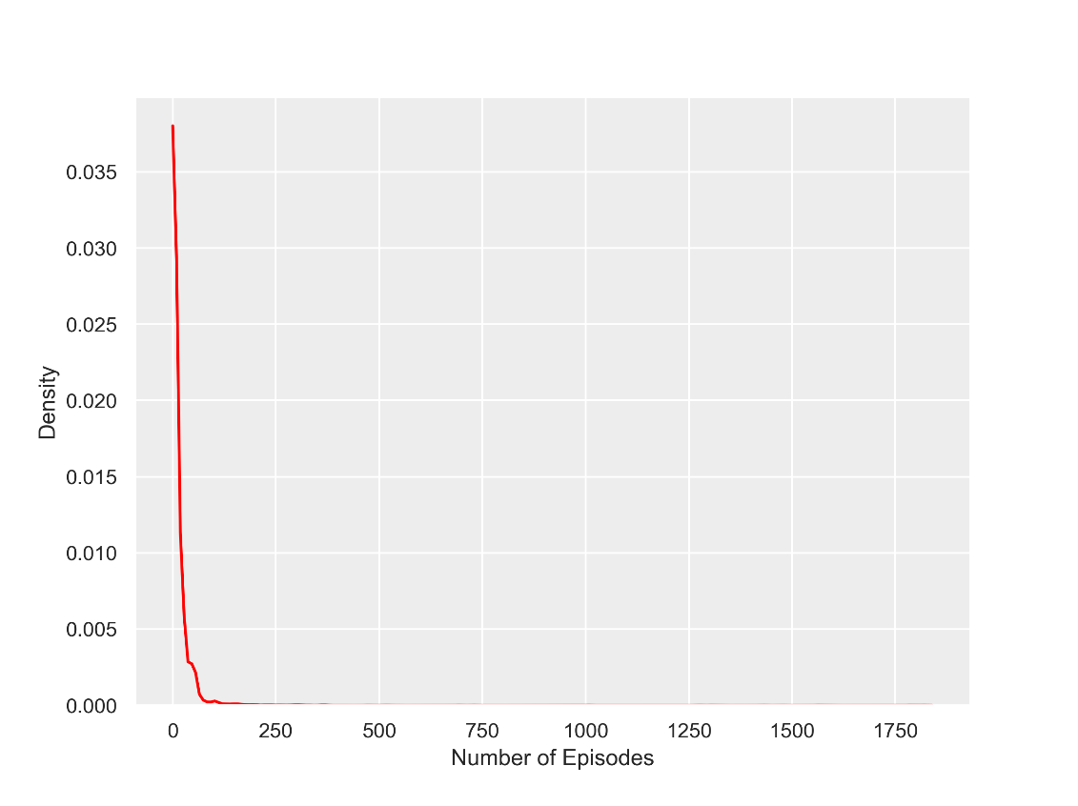

As per the visualization, it can be seen that number of episodes have definite impact on the ratings. However, for any anime great than 250 episodes a rating above 5 is always the case. This suggests than for an anime to release more than 250 episodes it needs a good rating or needs to be likeable so that people follow the anime.

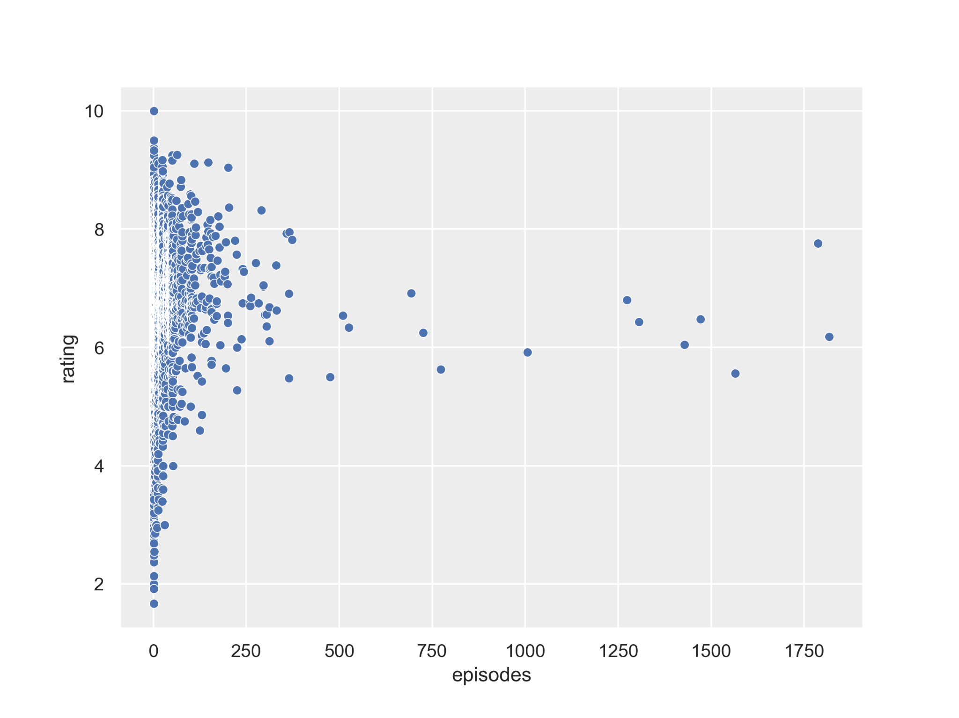

# Appendix

#### Data Link:

* <https://www.kaggle.com/CooperUnion/anime-recommendations-database?select=rating.csv>

#### Code Link:

* [Project-Otaku-An-Anime-Recommendation-Engine/BA Anime Recommendation Engine.ipynb at main · Ferdostto/Project-Otaku-An-Anime-Recommendation-Engine (github.com)](https://github.com/Ferdostto/Project-Otaku-An-Anime-Recommendation-Engine/blob/main/BA%20Anime%20Recommendation%20Engine.ipynb)